# **Project Plan - Salus: Healthcare application**

1: Identify the lifecycle to be followed for the execution of your project and justify why you have chosen the model.(PES2UG20CS549)

The software development life cycle that will be used to design and implement this project is **Agile methodologies**.

Agile life cycle includes:

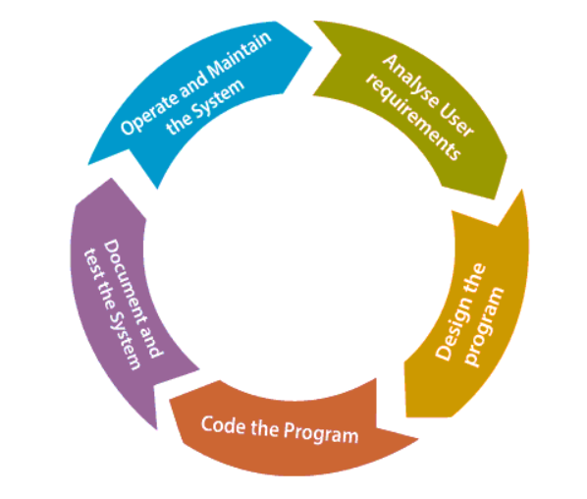

1. **Requirements gathering and analysis:** In this phase of the project, we understand the requirements that the product has including its functional and non-functional requirements. We compute the time and effort required to build the product.
2. **Architecture and Design:** After understanding the requirements, we identify the architecture to support the functionalities of the product and an initial design is created after which the design is reviewed in a meeting with stakeholders.
3. **Coding:** In this phase, we begin to code the project that has been designed.
4. **Deploy:** The software product is deployed in a user environment.
5. **Testing:** The product is tested for bugs and performance is evaluated.

The reasons for opting Agile methodologies are listed below:

1. **Superior quality product:** Project is divided into smaller units which enhances product quality. This feature is crucial in this project because of the critical functionalities like Emergency SOS which have to be fail-proof.
2. **Undivided focus on end-users:** In this method, functionalities are converted into user stories and prioritized which are based on acceptance criteria. This implies that the product must satisfy the end-users. Since the project is based on health care, it is important to understand what is beneficial to the end users and this feature of Agile helps in achieving that goal.
3. **Accommodations for change:** Agile works on a continuous feedback system where sprint meetings are held at short intervals and any change with respect to the product can be accommodated without it being very expensive or time-consuming. This gives us flexibility to change the product according to the customer and the user’s requirements as well as the technology.
4. **Risk reduction:** Agile focuses on deliverables after each sprint. Due to regular meetings with the client and the scrum team, any change in the backlog is quickly addressed and implemented which reduces the risk of product not satisfying the requirements due to inadaptability to change.
5. **Continuous improvement:** Through retrospective meetings, the scrum team reflects on the work done so far and what has to be improved. This means that throughout the development of the project, there is scope for improvement at every stage.
6. **Deliverables shipped faster:** Due to prioritization of user stories, deliverables are usually shipped after every sprint. In the domain of healthcare, it will be helpful for the users to deliver more crucial functionalities first and build the low priority functionalities on top of that.

2: Identify the tools which u want to use it throughout the lifecycle like planning tool, design tool, version control, development tool, bug tracking, testing tool.(PES2UG20CS552)

1. **Planning tool, bug tracking tool:** Jira Software, This is a work management, planning, bug tracking tool for all kinds of use cases.
2. **Design tool:** Draw.io, FlutterFlow
3. **Version control:** Github
4. **Development Tools:** Firebase (database management), FlutterFlow, Python

3: Determine all the deliverables and categorize them as reuse/build components and justify the same.(PES2UG20CS567)

**For the patients**

**a. Login Module:**

* Front-end Login page (Reusable component)
* Backend process to validate username and password (Reusable component)
* Username and password to be stored in database (Build component)

**b.Fitness Tracking Module**:

* Diet plan (Reusable component)
* Workout plan (Reusable component)
* Track menstrual cycle (Build component)

**c. Book appointment Module(To book doctors)**

* Search component - search doctor/symptoms (Build component)
* Profile component of doctors (Reusable component)
* Book screen (Build component)
* Payment (Reusable component)

**d . Order medication module**

* Search medicines (Template reuseable from previous module built)
* List medications (Reusable component)
* Cart screen (Build component)
* Payment (Reusable component)

**e. Medication reminder Module**

* List medications to take at specified time (Build component)

**f. SOS Module**

* Confirm button to call nearby authorities (Build component)
* HERE API to find location (Reusable component)

**For the doctors**

**a. Login Module:**

* Front-end Login page (Reusable component)
* Backend process to validate username and password (Reusable component)
* Username and password to be stored in database (Build component)

**b. Schedule Module**

* View appointments(Re usable)
* Accept appointments(Build component)
* Cancel appointments(Build component)

Database stores appointments and performs necessary operations when appointment is either accepted or canceled.

4: Create a WBS for the entire functionalities in detail.(PES2UG20CS567,PES2UG20CS549)

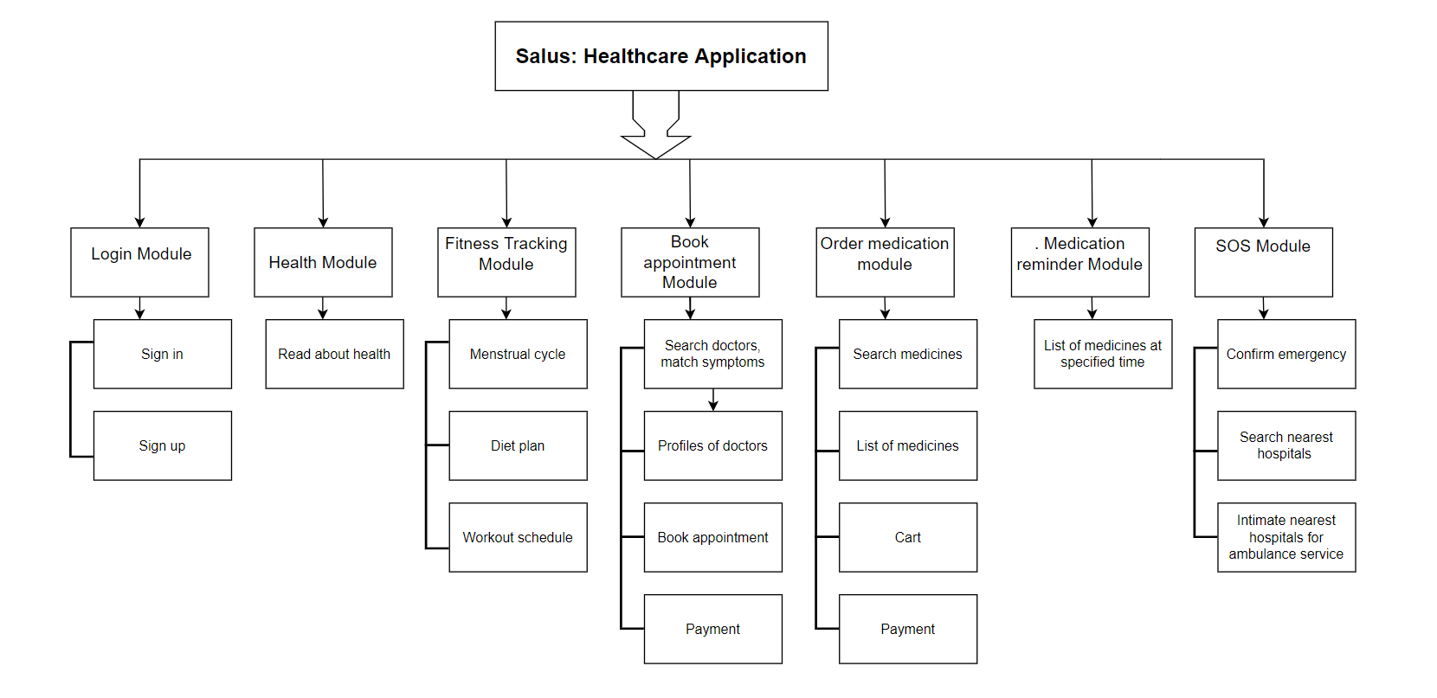

5: Do a rough estimate of effort required to accomplish each task in terms of person months.(PES2UG20CS552)

According to the Constructive Cost Model (COCOMO), the formula that relates Cost with Schedule is,

P = KLOC/E where,

P => Productivity,

KLOC => Kilo lines of code (the estimated size of the software product),

E => Effort (the total effort required to develop the software product, expressed in person months)

Assuming the value of KLOC to be 2.5 i.e, there are **2.5 kilo lines of code**.

This project is considered to be **organic**.

Effort = E = a1 * [(kLOC) ^ a2] (PM), where a1 = 2.4 and a2= 1.05

Effort = E = 2.4* [(2.5)^1.05] PM

Therefore,

**Effort = 6.28128 PM**

**Productivity = 2.5 KLOC/6.28128 PM = 0.398008KLOC/PM = 398.008LOC/PM**

6: Create the Gantt Chart for scheduling using any tool.(PES2UG20CS541)

**GanttPro** has been used for scheduling tasks.

